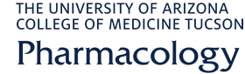

Seminar Series
Presents
“Evolving Studies of the Mechanisms Underlying
Post-Operative Pain”
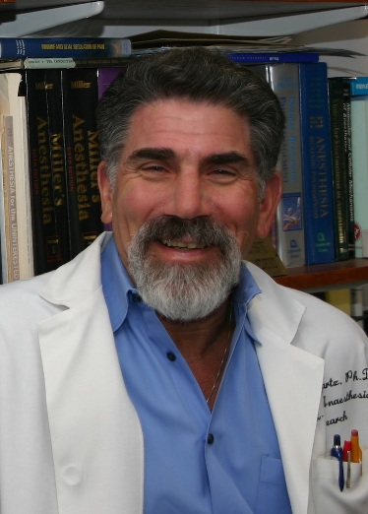By

Gary Strichartz, Ph.D.
Professor of Anesthesia and Pharmacology,
Harvard Medical School
Director, Pain Research Center
Brigham & Women’s Hospital Boston

Friday, August 25, 2017
12:00 pm – 1:00 pm
AHSC, Rm 8403

